Understanding Audience –

A Machine Learning Approach to Customer Segmentation

**Team Number:**

**Submitted To: SmartInternz Team**

**Batch: VIT – AP AI/ML Morning Batch**

**Year: 2023**

**DONE BY:**

**Vaishnavi T Sundari Dhulipala – 21BCE9174**

**Vintha Kuyili Ramyasri – 21BCE9204**

**Lakshmi Srujana Vankayala – 21BCE9181**

**Deepthimahanty Harshita – 21BCE9230**

PHASE – 1:

IDEATION PHASE:

Brain-Storming Map:

|  |  |
| --- | --- |
| Date | 23 October 2023 |
| Team ID | Team-591849 |
| Project Name | Project - Understanding Audience |
| Maximum Marks | 4 Marks |

**Brainstorm & Idea Prioritization :**

**Step-1: Team Gathering, Collaboration and Select the Problem Statement**

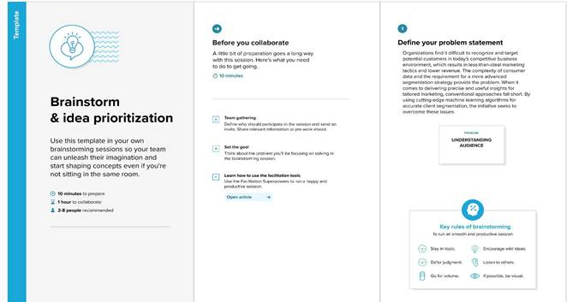

**Step-2: Brainstorm, Idea Listing and Grouping**

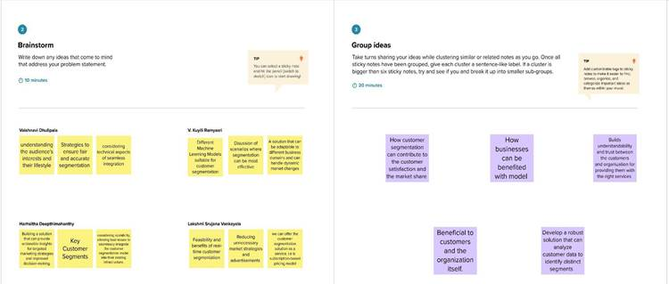

**Step-3: Idea Prioritization**

